

IHE Work Item Proposal (Detailed)

# Proposed Work Item: Cross Enterprise Basic eReferral Workflow Definition Profile

Proposal Editor:

Luca Zalunardo, lzalunardo@consorzioarsenal.it

Arianna Cocchiglia, acocchiglia@consorzioarsenal.it

Work Item Editor: Luca Zalunardo, Arianna Cocchiglia

Date: 11/02/2011

Version: 1.0

Domain: Patient Care Coordination

**Summary**

The management of the workflow related to clinical process has becoming a fundamental topic with the increasing of the use by different sectors of document sharing related IHE profiles with their different types of document and information.

This profile proposal born as development of the ITI XDW profile to manage the Cross Enterprise Basic eReferral Workflow. During last year, ITI has approved in Trial Implementation the Cross-Enterprise Document Workflow profile but the work done by ITI has been on the definition of the technical structure to manage a clinical workflow and not on the definition of the clinical processes, work left to the different domain.

The Cross Enterprise Basic eReferral Workflow is a proposal that shoots for:

* the definition of the workflow related to the eReferral. This workflow is involved in many clinical and organizational process for its important role in the process of digitalization. The definition of a workflow with fix rules and task is needed in a scenario cross enterprise in which many actors are involved in the same process. At the moment the lack of a standard method to manage the eReferral workflow produces a loss of about 56 million Euro in the Veneto Region (4.9 million of citizens and 22 million referrals issued each year);
* the definition of the structure of a typical Workflow Definition profile. This proposal will be, in fact, used by the different domain as an example to write a specific Workflow Definition profile.

The interest of the market in this topic is really high, especially in which country in which there is a public reimbursement for eReferrals. At a time of shortage, the government requests to improve the management of the spending to reduce the waste. A better management of the process related to the eReferral is one of the topic on which many regions and government are investing.

# The Problem

The management of the workflow related to clinical process has becoming a fundamental topic with the increasing of the use by different sectors of document sharing related IHE profiles with their different types of document and information.

This profile proposal born as development of the ITI XDW profile to manage the Cross Enterprise Basic eReferral Workflow.

The management of the workflow related to the eReferral is involved in many clinical and organizational process for its important role in the process of digitalization. The lack of a workflow management, at the moment, blocks the use of the eReferral in an extended way. Without an instrument which manage its workflow, the eReferral is only an order without any information about the status of the order itself. The definition of a workflow with fix rules and task is needed in a scenario cross enterprise in which many actors are involved in the same process.

To have a scale of the problem, an analysis has been performed on some data of the Veneto Region (4.9 million of citizens): now we have 22 million referrals issued each year. We have estimated that the introduction of the use of digital referral (eReferral) will entail a saving of about 56 million Euro thanks to:

* a better quality control of the process
* the reduction of the errors in the management of all clinical documents and related workflows
* the increasing of the efficiency of the process itself.

These data are based on the Veneto Region but the definition of a line guide international known for the eReferral workflow would increase this saving.

# Use Cases

A patient attends a consultation to his GP for a health problem. The practitioner examines him and some of his reports in relation with his health problem. After the visit, the practitioner prescribes an exam. The software of the doctor produces two objects: one eReferral and one Workflow Document to track the steps of the workflow of the eReferral and the document of interest related. In the Workflow Document, at the moment, there is one task which describe that the eReferral Workflow is in the step “ordered” and there are the references to the eReferral document and to all the clinical document which the practitioner has considered of interest.

From this moment the e-Referral is available to a wide range of care providers. The patient can call or go to a healthcare care provider of his choice to have the exam. The HCP, from the Hospital Information System, checks the step in which the e-Referral is and he books the visit. Once the visit has been booked, the HCP updates the Workflow Document to track that the visit has been booked. From this moment no other HCP can book the same visit.

After a few days the patient is admitted at the hospital, the HCP consults the e-Referral and the Workflow Document related and the process for the visit starts. The exam takes place and the doctor can analyze all the documents of interest related (such as the e-Referral and some reports that the GP has related) and proceeds with the exam. At the end, he generates the clinical report of the exam and updates the workflow document. The e-Referral Workflow is closed.

At any time, during this process, in case the patient visits his GP to assess progress, the GP may consult the Workflow Document and access related new document produced as a result of this execution of this workflow or any of its steps. This process is possible through a simple query and retrieve by the GP’s software to the Registry and Repository. It is also possible to manage a system of subscription and notification to communicate the progress between the different steps throw the use of the Document Metadata Subscription (DSUB) profile or the Notification of Document Availability (NAV) profile.



**Figure 3-1. Basic Process Flow**



Figure 3-2. Management of the Workflow Document

The work requested to PCC is on the definition of the clinical process and not on the definition of the technical structure of the workflow document (already done by ITI). The use case proposed is just an example and during the work of profiling it will be necessary to understand if it fits all the possible needs which can born from the different scenarios or if it needs some changes.

During this year the PCC working group should define:

* the tasks of the process arriving to a standard definition of the clinical process itself which could be globally accepted;
* the rules to move from one task to an other;
* the rules to define which actors can act for each task;
* the rules to define which document are expected to be produced for each task
* the codes for the tasks of the workflow
* etc.

# Standards & Systems

Afferent IHE Domains: IT Infrastructure, Patient Care Coordination

Afferent IHE Profiles – Existing: XDW, XDS, XDM, XDR, DSUB, NAV,BPPC, ATNA, CT, PIX, XUA, XCA

# Technical Approach

This profile proposal is a Workflow Definition profile so it is focused on the definition of the process and of the rules that relate the different steps of the process itself. The infrastructure used to manage the process has been defined by ITI with the Cross-Enterprise Document Workflow profile. This infrastructure is really flexible and on it many different clinical process can be managed. What differences one process to an other is the definition of the process shared between the different applications.

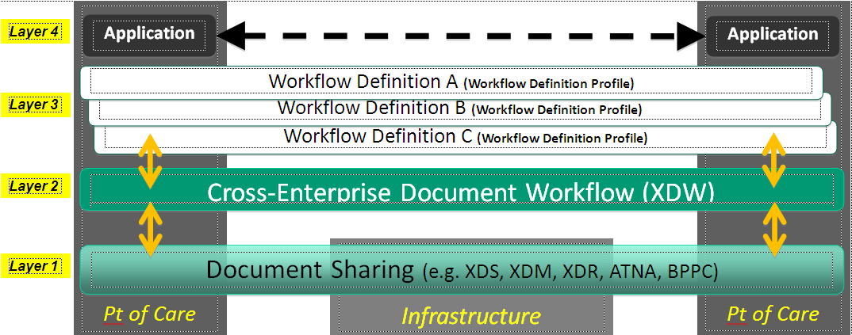

Figure 5-1 XDW Architecture Overview

In this workflow architecture:

* the first layer supports the sharing or exchange of documents. This interoperability foundation is enabled by a set of existing IHE document sharing profiles such as XDS, XDR and XDM along with document content profiles and security/privacy profiles such as ATNA and (optionally) BPPC;
* the second layer defines a generic data structure called a Workflow Document which is shared among the workflow participants by using the first layer of this architecture. Likewise, the clinical and administrative documents that are used as input and produced as output by the tasks of workflows managed by the XDW profile are shared using the same first layer of this architecture;
* the third layer introduces the semantic definition of the workflows, topic of this proposal, that can be understood and executed among the participating systems/applications. The orchestration of specific workflows allows the workflow participants to share a common understanding of the specific tasks, the dependencies between these tasks, and a number of rules that control the workflow execution. Execution details are conveyed through the XDW Workflow Document defined by the second layer of the architecture. The specification of Workflow Definitions at this third layer is not part of the ITI XDW Profile and is the scope of this proposal (See a basic example of Basic Unstructured Workflow Definition Profile, ITI TF-3:Appendix X);
* the fourth layer of this architecture contains the applications executed by the participating systems. Such applications bridge between XDW managed workflow and the locally managed workflow. Much of the details of the local workflows managed by each application will be hidden and encapsulated in “higher” granularity tasks exposed through XDW, as such details would not need to be externally exposed. The workflow definitions conveyed by the third layer should only contain higher granularity tasks that require workflow coordination across organizational boundaries

**New actors**

No new actors

**Existing actors**

XDW Content Creator, XDW Content Consumer, XDW Content Updater

**New transactions (standards used)**

None

**Impact on existing integration profiles**

This proposal defines a Workflow Definition profile that is needed by ITI-XDW to manage a clinical process. The Cross Enterprise Basic eReferral Workflow is the definition of the workflow for the eReferral which is at the basic element of many clinical process. In this sense, this profile would be the starting point of many others clinical processes.

This proposal would also be use as an example of Workflow Definition profile by other domains to structure a Workflow Definition profile.

**New integration profiles needed**

None

**Breakdown of tasks that need to be accomplished**

None

# Risks

This profile proposal does not have particular risk. The difficulties that can be find during the work of profiling could be on the standardization of the process itself which could have some variances in the different country. The process of the eRefferal, however, is sufficient simple and similar in the different country to find a common workflow. Moreover, the definition of a standard workflow is fundamental because the patients travel a lot through the regions and through the country and only a shared workflow can guarantee a correct management of eReferral workflow.

# Open Issues

In the case this profile will be extended in XCA multi-community infrastructures, a Change Proposal is needed in ITI. At the level of this proposal no changes are expected because the process is the same both in one community than cross-community.

# Effort Estimates

The work effort for profiling the XBeR-WD is estimated medium by planning. The work is focused on the definition of the clinical workflow and not on the definition of the workflow document structure (already defined by ITI). The effort has been evaluated medium not for the difficult to define the specific clinical workflow (the workflow of an eReferral is quite simple) but for the reason that this is the first time that a workflow definition profile is written and so some work is needed to define how a workflow definition profile has to be written.